作业1：
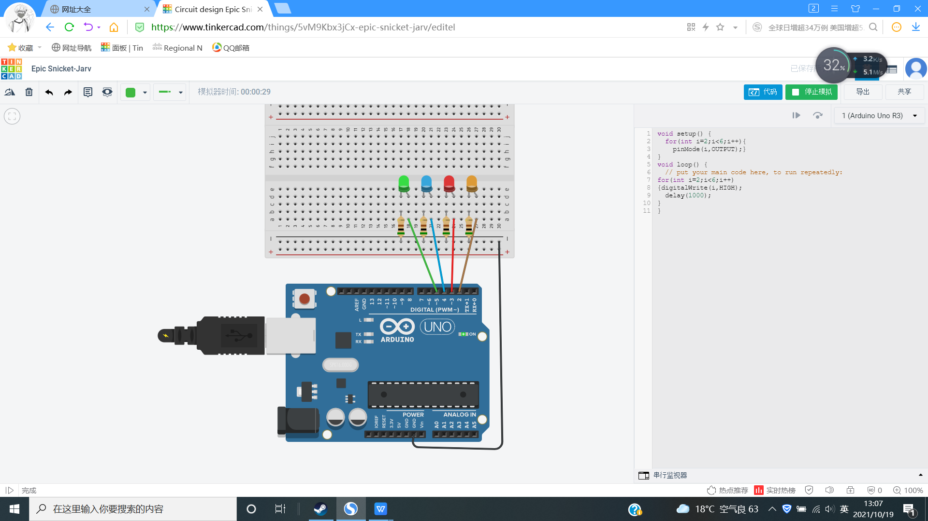
void setup() {
for(int i=2;i<6;i++){
pinMode(i,OUTPUT);}
}
void loop() {
// put your main code here, to run repeatedly:
for(int i=2;i<6;i++)
{digitalWrite(i,HIGH);
delay(1000);
}
}
作业2：

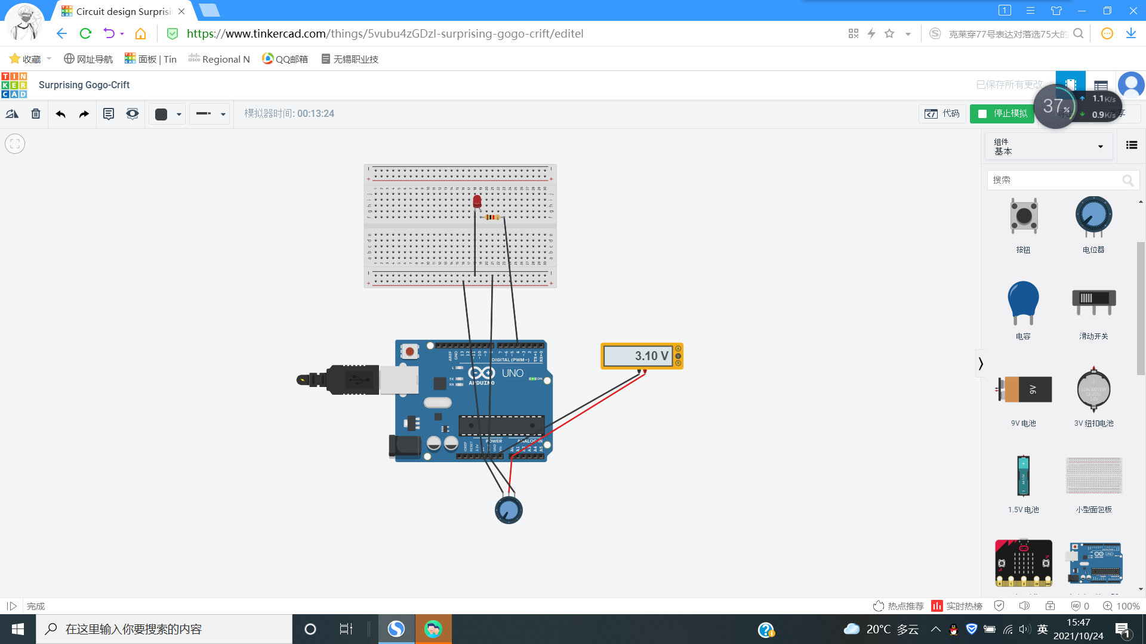

// C++ code
int ledPin =4 ;
int a0 = 0;
float val = 0;
void setup()
{
Serial.begin(9600);
}
void loop()
{
int sensorValue = analogRead(0);
float voltage= sensorValue * (5.0 / 1023.0);
Serial.println(voltage);
delay(100);
if(voltage>2.5){
digitalWrite(4,HIGH);
}else{
digitalWrite(4,LOW);
}
}

